**Venkataramanan** **K**

**DVI_GROUP002**

**DVI_ASSIGNMENT1PS2_BANKING DATA ANALYSIS**

**Ponvani**

**po**

**Balakavin Pon**

**Poornima J**

**Synopsis:**

This is an assignment on Data Visualization on Bank Campaign data. It is expected to perform the analysis on the given data and frame some important question and find out the answers by comparing the data attributes in various data visualization techniques. These answers will enable to understand the contributing factors for the success of the marketing campaign.

DATA VISUALIZATION AND INTERPRETATION

Assignment 1 on Bank Data Analysis

Submission on 10 Jan 2020

Assignment #1 | **Data Visualization**

**Bank Data Analysis**

**Venkataramanan K |** 2018AC04529

**Ponvani |** 2018AC04559

**Balakavin Pon |** 2018AC04531

**Poornima J |** 2018AC04550

Analysed and created in collaboration of

Group Information

Bits, pilani work integrated learning program



**DVI_GROUP002**

DVI Assignment 1 PS2 Bank Data Analysis

# Table of content

Table of content 3

Visualization Context 4

Business Problem 4

Who 4

What 4

How 4

Summary 4

Exploratory Data Analysis: 5

Age distribution: 5

Loan: 6

Chart 1: Age vs Campaign 10

Questions: 10

Analysis: 10

Inference: 11

Chart 2: effectiveness of campaign compared with social and economic measures 12

Questions: 12

Analysis: 13

Inference: 13

ChART 3: Campaigns against jobS and education 14

Question: 14

Analysis: 14

Inference: 15

Dashboard 16

Dashboard Actions 17

Recommendations & Suggestions: 18

# Visualization Context

## Business Problem

The bank wants to run a marketing campaign on the huge diversified financial product portfolio. In general, it is the responsibilities of the marketing team to conduct some campaign on time to time. They would log the details about those campaigns to do detailed analysis on the success and failure. The analysis on the data collected during the marketing campaign will provide an insight on the data and lead to provide recommendations or suggestions on the contributing factors for the successful purchase of the product. This will definitely enable the marketing team to focus on the significant factors to make the campaign more successful on selling the product to customers.

## Who

Management and Board members of the bank. They are the target audience for the analysis and outcome of the marketing department campaign on their financial products.

## What

The primary objective of this analysis is to understand and get an insight about the previously conducted market campaign on the bank products to various types of customers. The outcome of the analysis will contain the suggestions and recommendation to give a direction to leaders of the organization and the marketing department about both the success factors and needs to improvement factors. This will give them an insight on where they need to improve their marketing strategy to make it more effective.

## How

During the marketing campaign the department gathered the data as a log of process and outcomes. At the end of the campaign these data will be used for analysis to identify the contributing factors for the success of the campaign and area of focus to improve the campaign more effectively.

## Summary

**Who:** Bank Senior Management Executives for funding and approving such marketing campaign in future.

**What:** The marketing campaign was moderately effective and analysis outcome will give clear insights on where to focus on improving the effectiveness

**How:** Demonstrate the results of the campaign with collected data after the market campaign and sales of their financial product.

## Exploratory Data Analysis:

There are around 41188 marketing campaign data are available, out of which 4640 i.e. 11.27% of people had purchased the product.

### Age distribution:

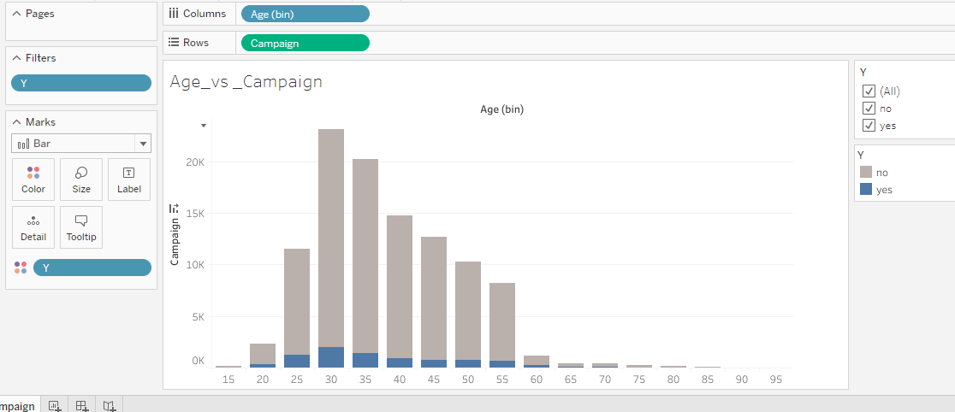

**Inference:** People between the ages 25 to 40 are active customers.

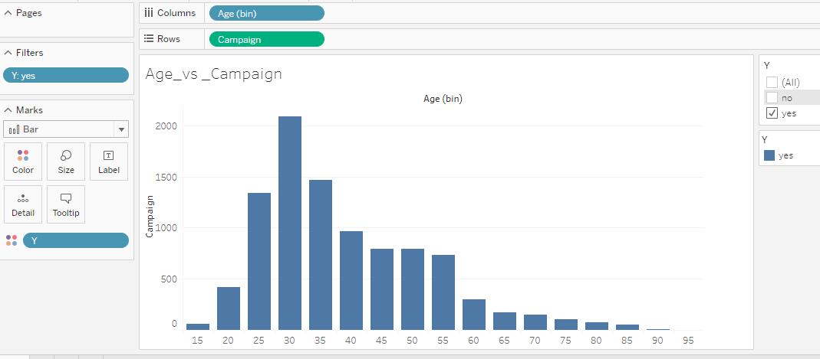

### Loan:

**Defaulter:** 90% of People who are Non defaulter are purchasing. 10% are unknown.

We can target the non-defaulters.

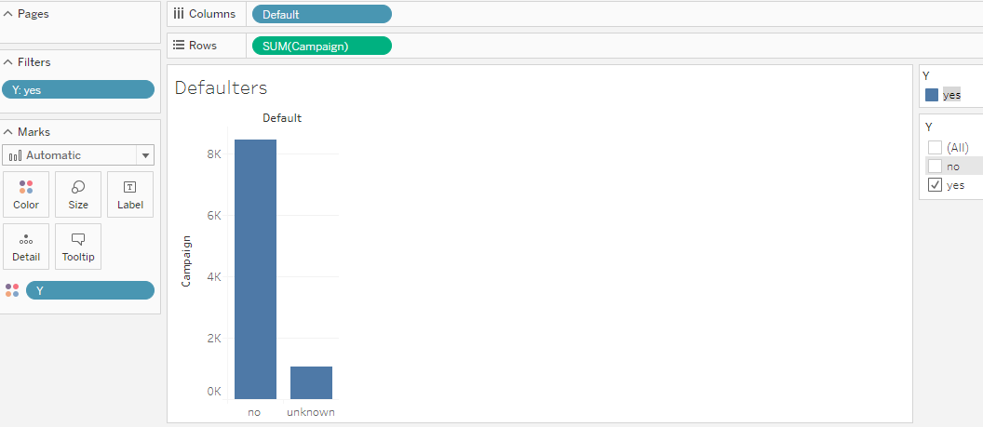

**Mode of Contact:**

83% of people are contacted via cellphone had purchased.

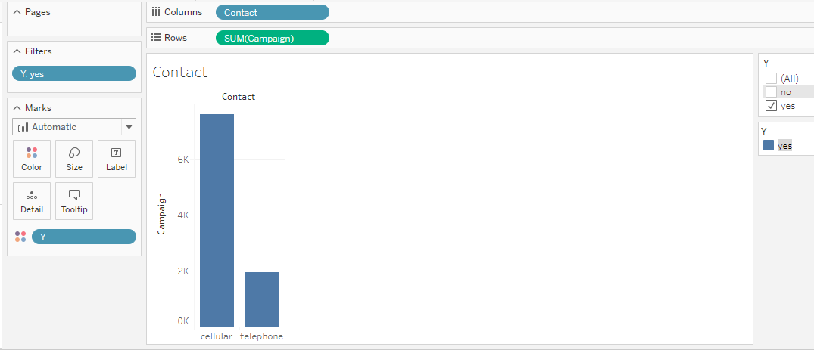

**Loan:** Has personal loan?

82% of people who are not having personal loans are purchasing.

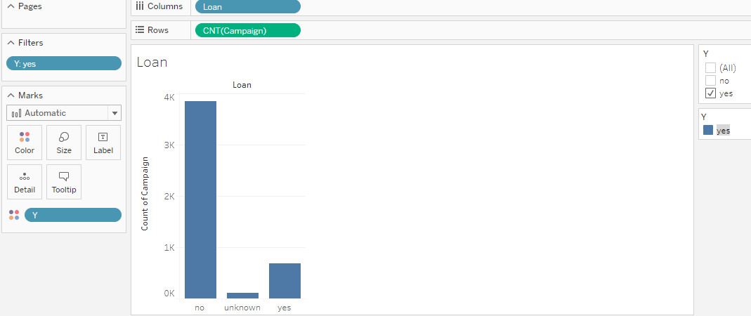

**Housing:** has housing loan?

Not a major difference between the People having/not housing loan.

54.03% of people who are having housing loan had purchased

43.66% of people who did not purchase are not having housing loan.

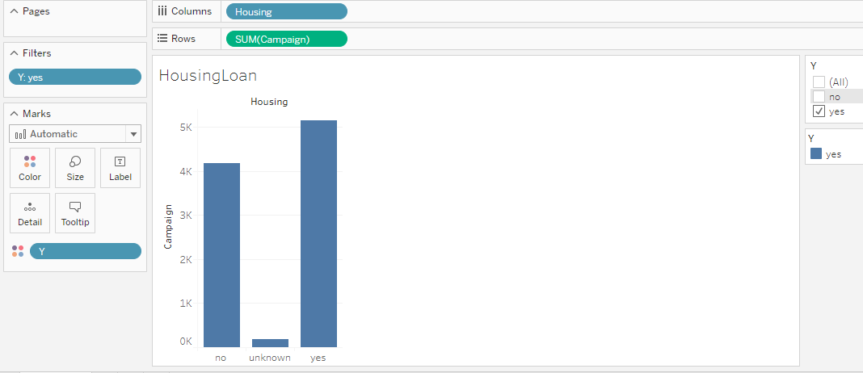

**Month:** It is observed that Dec month is having less than 2% percentage of purchase and no records for Jan and Feb. So, it is better to avoid during year end and jan&feb.

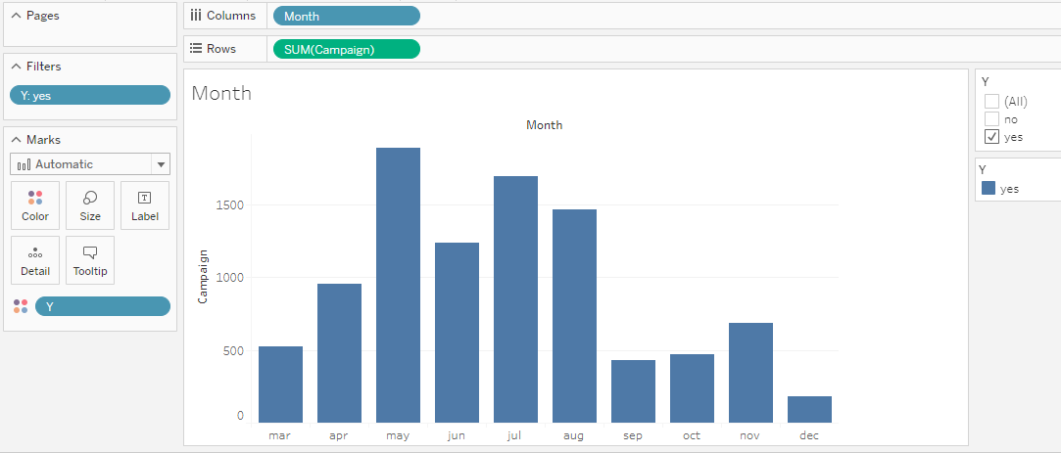

**Marital:** 50% of married people are purchasing.

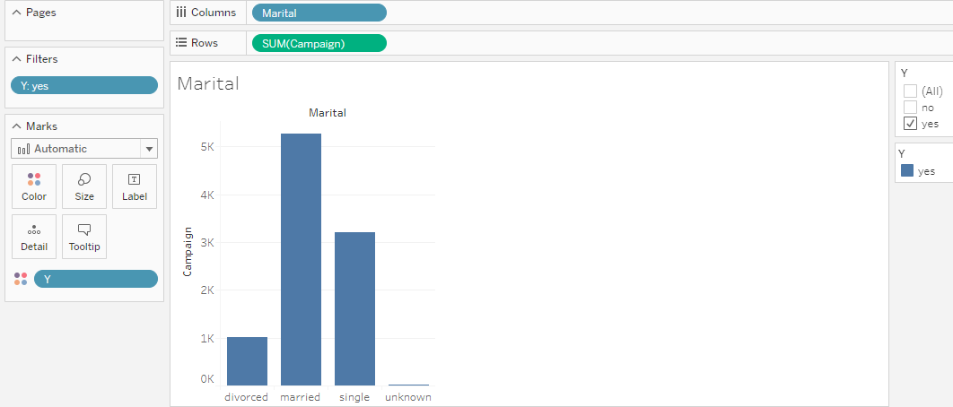

**Pdays:** (number of days that passed by after the client was last contacted from a previous campaign

999 means client was not previously contacted.)

79% -it is evident that people who are **Newly** contacted or contacted within 1st week after campaign are purchasing.

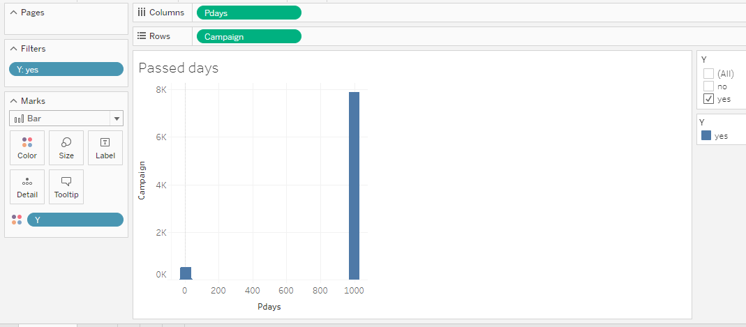

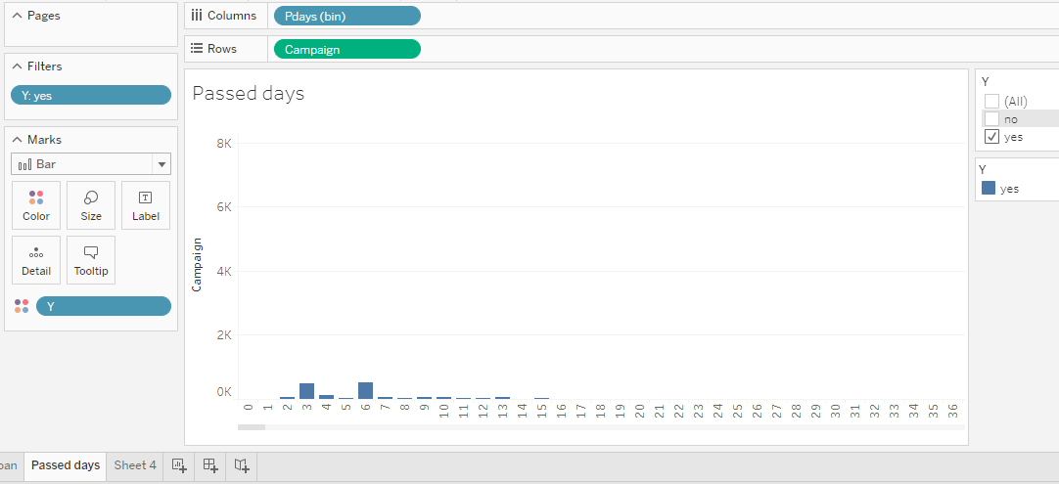

# Chart 1: Age vs Campaign

### Questions:

1. Do we need to change the campaign strategy based on the age group of a customer? Or same campaign can be used for all age group?
2. Which Age group of customers had received the campaign positively and shown a significant result?

### Analysis:

As per our analysis we have noticed that a greater number of people between the age **25 to 45** have purchased the products. We want show this as a visualization by grouping age using Bin to see the count of the age grouped against number of people purchased.

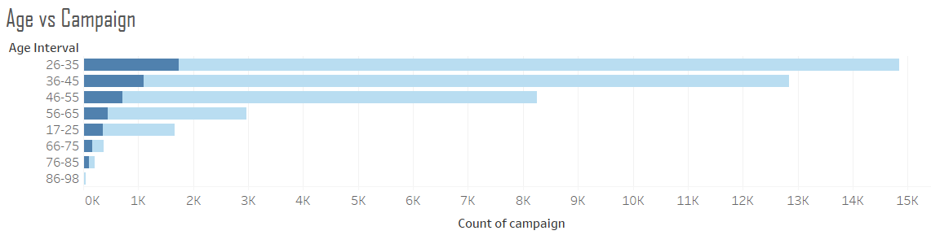We have used an inverted Bar chart, which helps to compare the number of campaign (in x axis) against the age interval (in y axis).

We also showed that, how many people we have contacted for campaign and how many people have successfully purchased using the color option in same bar chart.

This carries lot of information without any clutter.

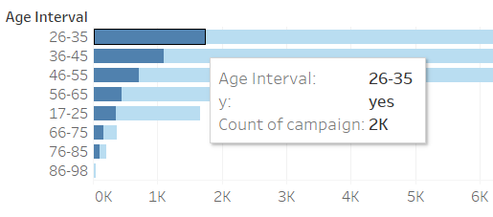The analysis gave an indicative perspective on which age group needs to be targeted for the financial product campaign. The age group on both extremes as young population (17-26) and old population from (76-98) did not show any significant effect on the buying the products. Which is very evident that these age group people are not much inclined in investing financially.

### Inference:

The outcome of this analysis shows us that the campaign is highly effective in the age group 26-45 and moderately effective in 46-55. At the same time, the campaign should be made separately to suit the age group of the customer rather than having single campaign for all the age group.

# Chart 2: effectiveness of campaign compared with social and economic measures

### Questions:

**Consumer Price Index(CPI)**

1. On the given consumer price index(CPI), how did the campaign performed among the customer base?
2. Is there any correlation on Consumer Price Index(CPI) and purchase of the product?

**Average Employment Vacancy Rate**

1. How did the campaign perform against the average employment vacancy rate(AEVR) on different months?
2. Was there any significant relation between product purchase on the AEVR?

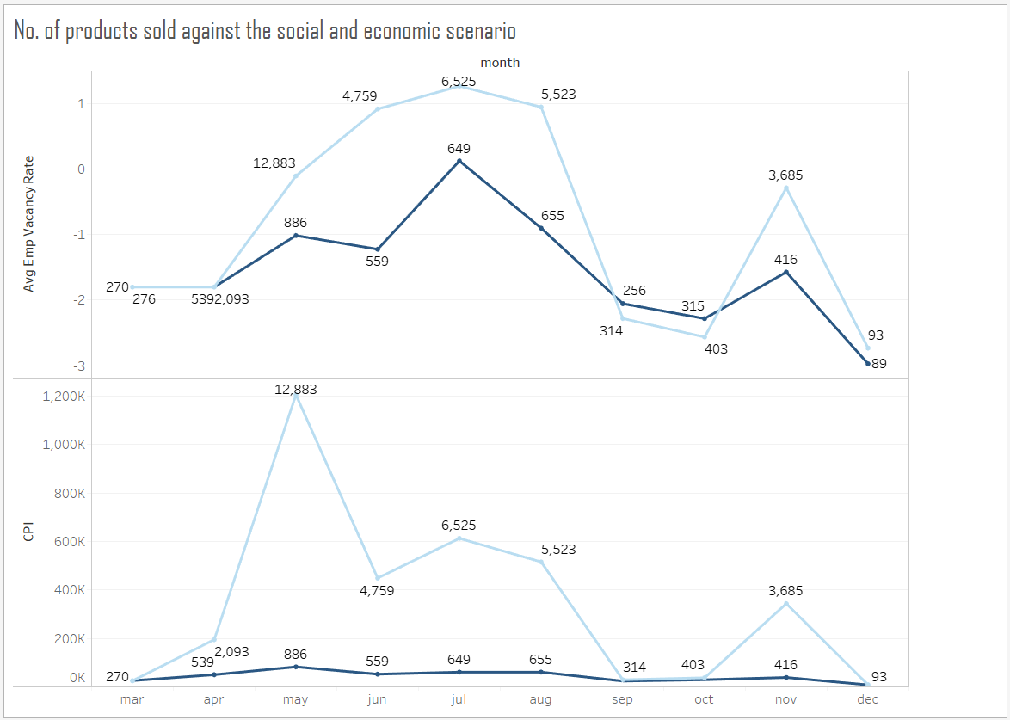

### Analysis:

In the analysis, the variables CPI and Average employment vacancy rate were compared with the campaign conducted across the months of the year. We have found that there is an increase in purchase when there is positive Avg. Emp. Vacancy rate (**> 0.5**). On the other hand, the non-purchase count and purchase counts were almost equal when the AEVR rate is **<=-2**.

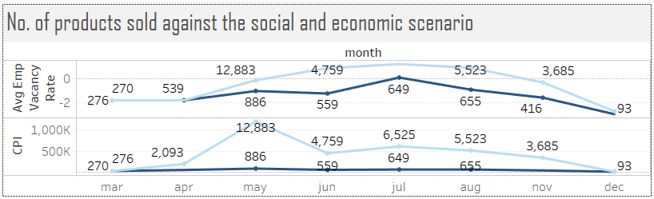

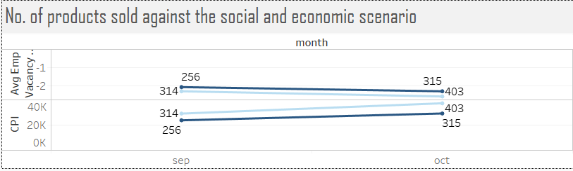With respect to CPI measures, there is no significance change on the product purchase counts, they were almost a straight line across all the months. Whereas, we could see a peek raise on non-purchase counts during the period of Apr to May and steady decline from May to June. During that time there is an increase in the CPI rate as well, which could make the people to not invest in any Banking scheme rather, spending nature of people might be higher.

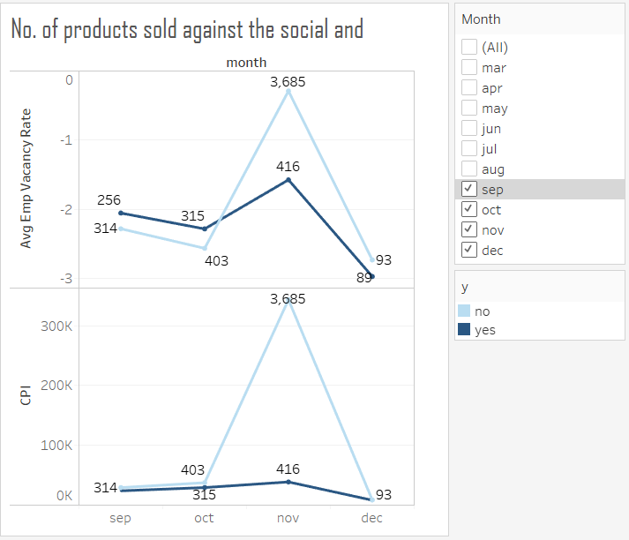In a similar fashion, after the month September there is a decline trend on both purchase and non-purchase count where the AEVR values also going deep belowless than **-2.5.**

If we take a look at the graph of CPI there is a sudden raise of non-buyers count during Oct-Nov month and then there is a steep decrease in count.

### Inference:

The average employment vacancy rate is a contributing factor on the performance of the campaign. We need to be sure the rate of average employment vacancy. When the vacancy is higher the conducting campaign on investing in bank products or scheme is not a wise idea. On the other hand, when the CPI is less than **<100K** then there was a steady margin on buying the product. However, there are no significant increase in purchase is seen when the CPI is increased more than **100K**.

# ChART 3: Campaigns against jobS and education

### Question:

1. Is there any relationship between customers education, job and purchase of financial products?
2. How do the customer’s education qualification and occupation influence on buying financial products after campaign by the marketing team?
3. Which sector of customers should be targeted by the marketing department based on their education and job?

### Analysis:

We have noticed that people who are illiterate does not buy. Then we drilled down and checked that a greater number of people who have completed University and professional degree have purchased more.

People who are working as Admin have purchased more. So, we wanted to compare the count of people who are interested in buying against each profession. also, we wanted to categorize the people against education as well.

The following stacked bar chart depicts the comparison between job, education and campaign count.

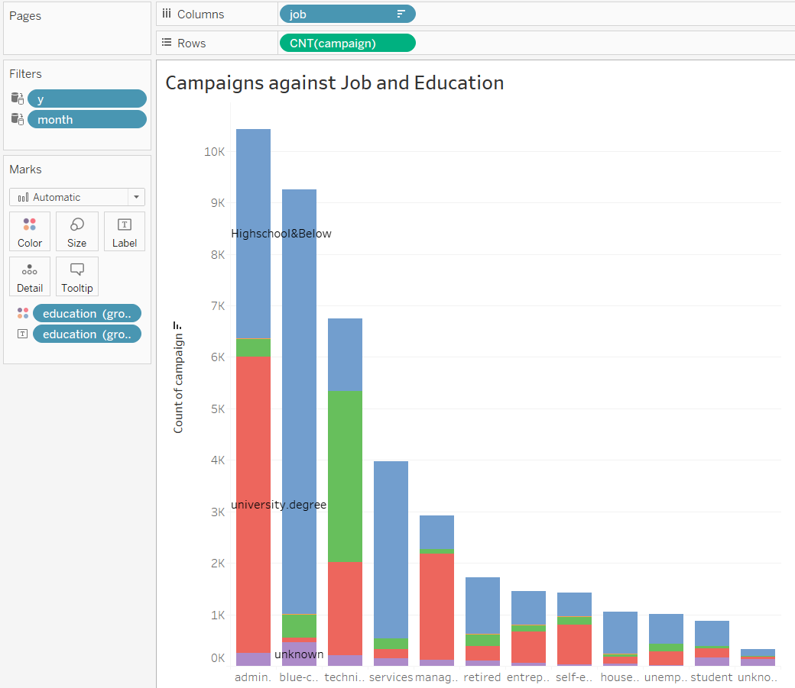

### 

When we wanted to see whether these job and education variable contributed on purchasing the financial products after the campaign was conducted, we found that the customers having University degrees and High school education have bought the products than compared to illiterate or no education customers.

### 

### Inference:

After the comparison and analysis on the customer’s education and job attributes against the campaign data, it is very evident that the customers who have high school and above (university or professional degree) have been attracted by the campaign which also made them to buy the products.

# Dashboard

A dashboard plays a vital role in data visualization, which is an information management tool that visually tracks, analyses and displays key performance indicators (KPI), metrics and key data points to monitor the process, health of the business or department performance. After the series of data explorations and analysis based on context specific questions, we made a dashboard to highlight some important metrics and data points along with few interactive elements such as filters and clickable legends.

The following dashboard shows the outcome of three important analysis we performed on the bank campaign data.

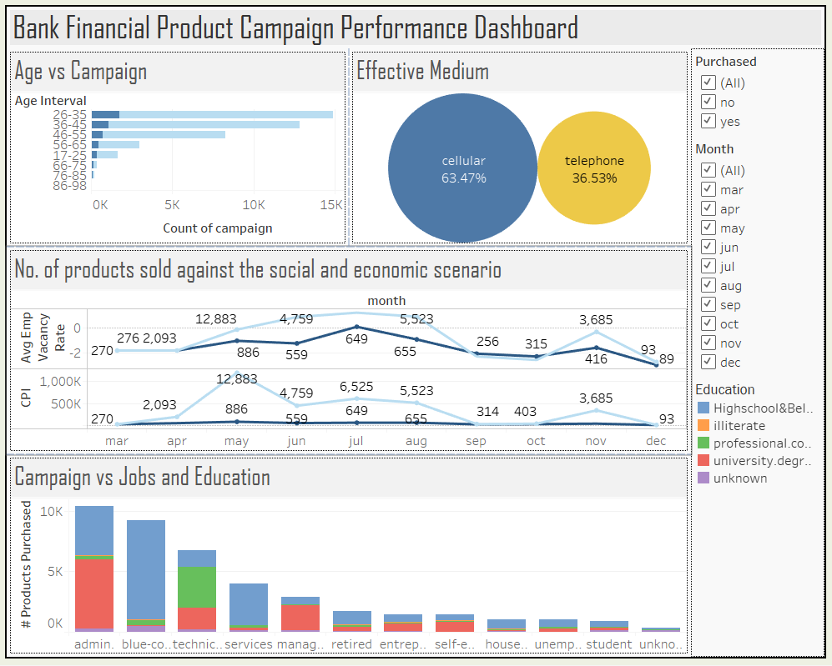

### Dashboard Actions

Dashboard actions will enable the dashboard interactive relationships between the data and data objects thus they perform certain operations such as filtering, highlighting, change parameters, change set of values etc. in a cohesive manner. We have added two actions in this dashboard, both are filter actions. The data elements in the graph changes based on the selection of values of the chosen attribute.

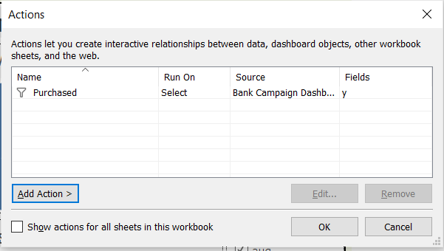The filter action “Purchased” run on select option which triggers the filter operation on the graphs on the dashboard based on the attribute value selection. If the purchased “Yes” is selected then all the data in the graphs related to Yes will be shown, otherwise the data of No will be shown when No is selected.

The below picture depicts the mechanism of dashboard filter action. When the Purchased option yes is selected, the data in all the graphs have been changed with respect to the value “Yes”.

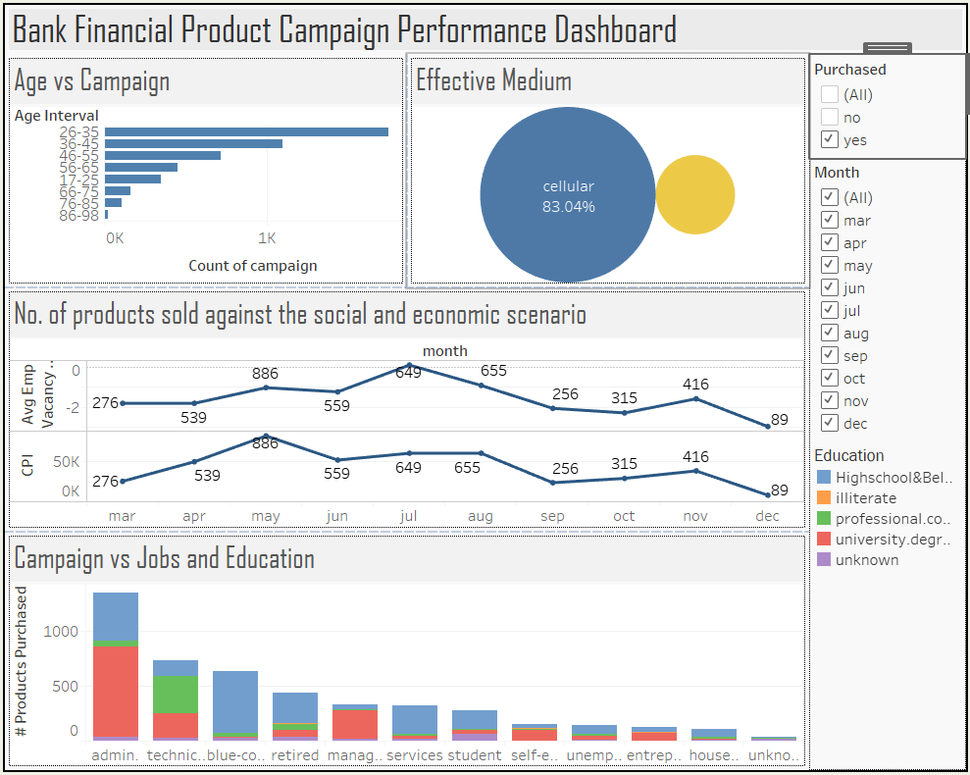

# Recommendations & Suggestions:

1. **Mode of Communication:** 83% of the customers who were contacted on their mobile phone had purchased the product than the customers who were reached over telephone.
   1. Mobile device is more personalized than telephone as it could be for members in home and office. This indicates that customers are interested when they are contacted through mobile.
   2. We recommend the marketing department to focus on the medium of communication their customers for any campaign program.
2. **Target the right age group:** **26-35** is the age group of the customers who bought most product after the campaign, the second-best age group is **36-45**. Rest of the age group are not impacted by the campaign very much. The marketing team should be targeting the age group of 26-45 to sell the financial products.
3. **Focus of non-defaulters:** The customers who have had a good credit rating have responded well with the campaign. The customers who had loans and not a defaulter have purchased the product after the campaign.
4. **Middle Income Group:** The campaign worked well for the middle-income job group. The job category admin and technician have responded well with the campaign. Out of these two categories, people who have minimum high school and university degree have bought the financial products. We recommend the marketing team to consider the factors education qualification and job profile of the customer before the campaign.
5. **Socio-Economic scenario:** The campaign result is much oriented towards the socio-economic state of the people. When the Consumer Purchase Index(CPI) high the customer did not show interest in investing money in bank. The graph shows the purchase of financial product is almost a stationary through the period. Whereas, the Avg.employment vacancy rate had an implication on purchasing the products. When the average employment vacancy low, there are increase in financial investment. This could be caused by the general belief on securing their financial state when the time is bad. So people responded well with the campaign.